Batch Processing Architecture for GTFS Dataset

### Introduction

The aim of this project is to design a robust, cost-effective, and scalable batch processing pipeline for the GTFS (General Transit Feed Specification) dataset, using only online services to reduce complexity and operational overhead. The GTFS dataset contains essential public transit data, including stops, trips, and routes, all of which are highly time-referenced and suitable for large-scale batch processing. This system is built with an emphasis on reproducibility, security, and ease of deployment—using online tools such as Google Drive, Google Colab, GitHub, and (optionally) Google BigQuery and Looker Studio for analytics and reporting.

### System Architecture Overview

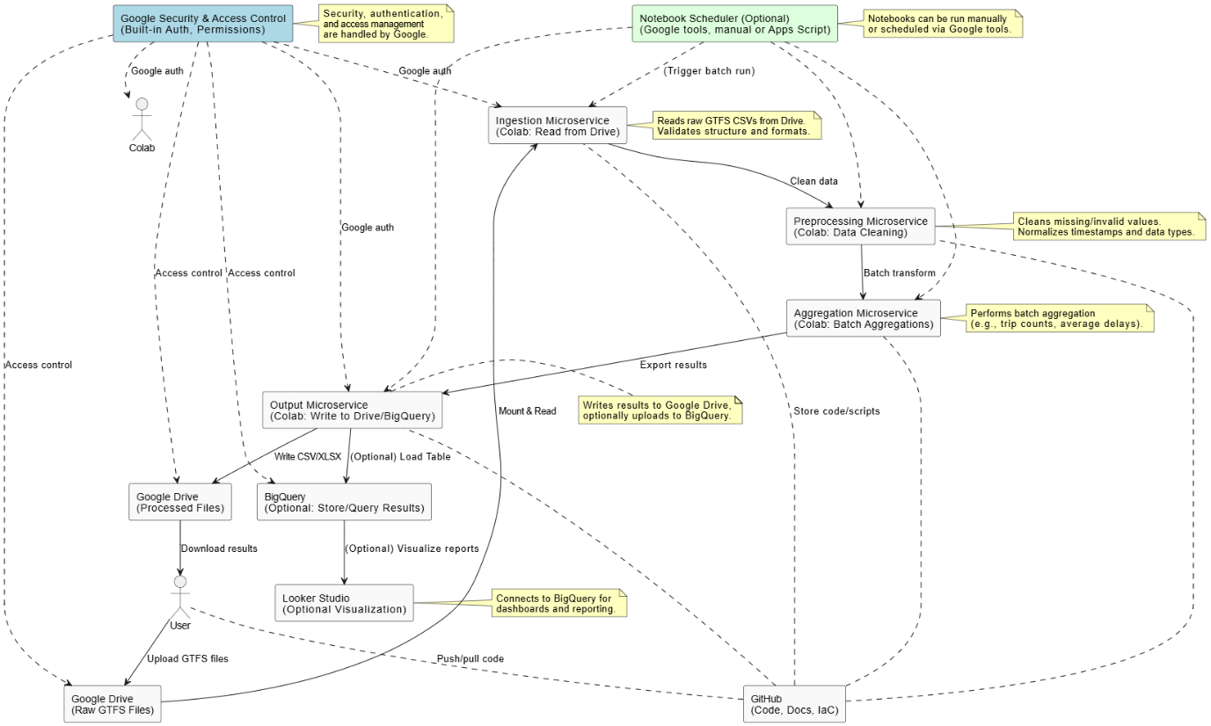

The proposed architecture follows a modular, microservices-inspired design with clear logical separation between data ingestion, preprocessing, aggregation, and output stages. As this solution is fully online and leverages managed cloud services (Google Drive, Google Colab, BigQuery), explicit Docker images are not required for the implementation. Sample Dockerfiles are provided in the repository to demonstrate Infrastructure as Code (IaC) and ensure reproducibility, should containerized deployment be needed in future scenarios. All components leverage cloud-managed services, ensuring reliability, maintainability, and minimal cost. The workflow is as follows:

1. **Data Ingestion Microservice:**
   * Implemented as a Google Colab notebook/script, this microservice reads raw GTFS CSV files stored on Google Drive, validates their structure, and prepares them for processing.
2. **Preprocessing Microservice:**
   * This module, also in Colab, cleans the ingested data by handling missing values, normalizing timestamps, and ensuring data consistency.
3. **Aggregation Microservice:**
   * Batch aggregation operations (such as calculating trip counts, average delays, or summarizing route statistics) are performed using PySpark or Pandas in Colab.
4. **Output Microservice:**
   * The results of processing and aggregation are written back to Google Drive as CSV or Excel files. Optionally, output can be loaded into Google BigQuery for further analysis or visualization in Looker Studio.
5. **Orchestration/Scheduling:**
   * Batch jobs are typically triggered manually via notebook runs but can be automated in the future using Google-native scheduling tools if required.
6. **Version Control and Reproducibility:**
   * All code, configuration, and documentation are version-controlled in GitHub, following Infrastructure as Code (IaC) principles for maximum transparency and reproducibility.
7. **Security & Access Control:**
   * Security and permissions are managed entirely through Google’s built-in authentication and access control systems, ensuring data privacy and integrity without additional user-side configuration.

### Justification for Technology Choices

1. **Google Drive:** Cloud-based storage with straightforward sharing and authentication. Handles raw and processed data storage seamlessly.
2. **Google Colab:** Provides a no-cost, managed execution environment for batch processing (with support for Python, PySpark, and notebook workflows). No local setup is required.
3. **GitHub:** Industry-standard version control platform. Enables collaborative development, documentation, and demonstration of Infrastructure as Code (IaC).
4. **Google BigQuery (Optional):** Allows scalable analytics and reporting for large datasets. Ideal for demonstrating further analytics, should project requirements expand.
5. **Looker Studio (Optional):** Cloud-based dashboarding, easily connected to BigQuery for real-time data visualization.
6. **Cloud Security & Scheduling:** Managed by Google’s built-in systems, eliminating the need for custom setup or third-party security tools.

### Techniques for Reliability, Scalability, and Maintainability

1. **Reliability:**
   * Google Drive and Colab are highly available, cloud-managed platforms.
   * All data is stored redundantly in the cloud, minimizing risk of data loss.
2. **Scalability:**
   * Google Colab and BigQuery scale easily for larger datasets or more complex batch jobs.
   * Architecture can be extended to additional cloud services as needed without major rework.
3. **Maintainability:**
   * Clear separation of each microservice step into logical modules/notebooks/scripts.
   * Version control with GitHub enables easy tracking of changes and collaborative development.
   * Documentation and workflow diagrams included in the repository.

### Techniques for Data Security, Governance, and Protection

1. **Authentication & Access Control:**
   * All data and code access is controlled via Google and GitHub’s cloud authentication systems.
   * Permissions and sharing settings are managed centrally, reducing risk of unauthorized access.
2. **Data Integrity & Validation:**
   * Rigorous validation and cleaning steps are integrated into preprocessing to maintain data quality.
3. **Governance:**
   * Auditability is ensured through code versioning in GitHub and data versioning in Drive.
   * Optional logging and cell output storage in Colab for traceability.

### Data Used for the Project

1. **GTFS Dataset (Germany or similar):**
   * Includes time-referenced tables for stops, trips, routes, and stop-times, satisfying requirements for data volume (>1,000,000 records) and timestamps.

### System Frequency

1. **Data Ingestion:**
   * Performed as needed by uploading new GTFS files to Google Drive.
2. **Batch Processing and Aggregation:**
   * Triggered manually via Colab notebook runs, simulating quarterly batch jobs.
3. **Data Delivery:**
   * Processed outputs are made available on Google Drive and optionally uploaded to BigQuery for reporting and dashboarding.

### Advantages and Disadvantages of This Conceptual Draft

**Advantages:**

1. Minimizes setup complexity by relying on managed, online services—no local configuration headaches.
2. Secure, scalable, and easily reproducible that’s suitable for academic and professional demonstration.
3. Highly modular so each logical microservice can be developed and tested independently.

**Disadvantages:**

1. Processing resources are limited by free tier constraints (e.g., Colab runtime timeouts, BigQuery quotas).
2. Not suitable for real-time streaming or very high-frequency batch jobs without upgrades or paid tiers.
3. Some manual steps (like uploading data or running notebooks) may be required, though these can be automated in the future.

### Conclusion

This conception phase proposes a fully online, microservices-based batch processing pipeline for GTFS data using Google Drive, Google Colab, GitHub, and optionally BigQuery and Looker Studio. The solution is robust, scalable, secure, and reproducible, while keeping operational complexity and cost at an absolute minimum. This approach demonstrates modern data engineering principles using accessible cloud technology, meeting all requirements for reliability, scalability, maintainability, and data governance.